LAB INTERNAL EXAMINATION – E-COMMERCE USER MANAGEMENT
Experiment – 5: User Signup and Signin
Aim
To create a User Entity in a Spring Boot application and implement REST APIs for user signup and signin using a MySQL database. Passwords are stored as BCrypt hashes. The APIs are tested using Thunder Client, and the registered user is verified in the database.
Software Requirements
- Java JDK 17
- Spring Boot 3.x
- Maven
- MySQL 8
- Thunder Client (VS Code extension)
- VS Code / IntelliJ IDEA / Spring Tool Suite

Technologies Used
- Backend: Spring Boot
- Programming Language: Java
- Database: MySQL
- ORM: Spring Data JPA / Hibernate
- Password Security: BCrypt (spring-security-crypto)
- API Testing: Thunder Client
- Build Tool: Maven
1. Project Creation
Create a new Spring Boot project with the following configuration (start.spring.io):
Property | Value
Project | Maven
Language | Java
Group | com.example
Artifact | ecommerce
Packaging | Jar
Java | 17

Required Dependencies
Add the following dependencies:
- Spring Web
- Spring Data JPA
- MySQL Driver
- Validation
After generating the project, replace the content of pom.xml with the code below. It also adds spring-security-crypto, which provides BCrypt.
File: pom.xml
<?xml version="1.0" encoding="UTF-8"?>
<project xmlns="http://maven.apache.org/POM/4.0.0"
xmlns:xsi="http://www.w3.org/2001/XMLSchema-instance"
xsi:schemaLocation="http://maven.apache.org/POM/4.0.0 https://maven.apache.org/xsd/maven-4.0.0.xsd">
<modelVersion>4.0.0</modelVersion>

<parent>
<groupId>org.springframework.boot</groupId>
<artifactId>spring-boot-starter-parent</artifactId>
<version>3.3.5</version>
<relativePath/>
</parent>

<groupId>com.example</groupId>
<artifactId>ecommerce</artifactId>
<version>0.0.1-SNAPSHOT</version>
<name>ecommerce</name>
<description>College ECommerce - Experiment 5: User Signup and Signin</description>

<properties>
<java.version>17</java.version>
</properties>

<dependencies>
<dependency>
<groupId>org.springframework.boot</groupId>
<artifactId>spring-boot-starter-web</artifactId>
</dependency>
<dependency>
<groupId>org.springframework.boot</groupId>
<artifactId>spring-boot-starter-data-jpa</artifactId>
</dependency>
<dependency>
<groupId>org.springframework.boot</groupId>
<artifactId>spring-boot-starter-validation</artifactId>
</dependency>
<dependency>
<groupId>com.mysql</groupId>
<artifactId>mysql-connector-j</artifactId>
<scope>runtime</scope>
</dependency>
<dependency>
<groupId>org.springframework.security</groupId>
<artifactId>spring-security-crypto</artifactId>
</dependency>
</dependencies>

<build>
<plugins>
<plugin>
<groupId>org.springframework.boot</groupId>
<artifactId>spring-boot-maven-plugin</artifactId>
</plugin>
</plugins>
</build>
</project>

2. Database Configuration
Create a MySQL database named:
CREATE DATABASE ecommerce;

After creating the database, configure the database connection in:
src/main/resources/application.properties
program:
spring.datasource.url=jdbc:mysql://localhost:3306/ecommerce
spring.datasource.username=root
spring.datasource.password=YOUR_MYSQL_PASSWORD

spring.jpa.hibernate.ddl-auto=update
spring.jpa.show-sql=true
spring.jpa.properties.hibernate.dialect=org.hibernate.dialect.MySQLDialect

server.port=8080

Note: replace YOUR_MYSQL_PASSWORD with your own MySQL password.
3. Project Structure
Create the folders controller, dto, entity, exception, repository and service inside com/example/ecommerce.
src
└── main
├── java/com/example/ecommerce
│ ├── controller
│ │ └── UserController.java
│ ├── dto
│ │ ├── ApiResponse.java
│ │ ├── SigninRequest.java
│ │ ├── SigninResponse.java
│ │ └── SignupRequest.java
│ ├── entity
│ │ └── User.java
│ ├── exception
│ │ ├── EmailAlreadyExistsException.java
│ │ ├── GlobalExceptionHandler.java
│ │ ├── InvalidCredentialsException.java
│ │ └── UserNotFoundException.java
│ ├── repository
│ │ └── UserRepository.java
│ ├── service
│ │ └── UserService.java
│ └── EcommerceApplication.java
└── resources
└── application.properties

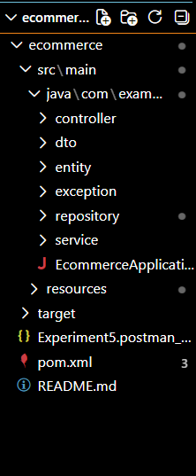
The request flow is:
Thunder Client
↓
UserController
↓
UserService
↓
UserRepository
↓
MySQL Database

4. Update Main Application Class
This class starts the application and creates the BCrypt password encoder.
File: src/main/java/com/example/ecommerce/EcommerceApplication.java
package com.example.ecommerce;

import org.springframework.boot.SpringApplication;
import org.springframework.boot.autoconfigure.SpringBootApplication;
import org.springframework.context.annotation.Bean;
import org.springframework.security.crypto.bcrypt.BCryptPasswordEncoder;
import org.springframework.security.crypto.password.PasswordEncoder;

@SpringBootApplication
public class EcommerceApplication {

public static void main(String[] args) {
SpringApplication.run(EcommerceApplication.class, args);
}

// One shared BCrypt encoder, injected into UserService
@Bean
public PasswordEncoder passwordEncoder() {
return new BCryptPasswordEncoder();
}
}

5. Create User Entity
File: src/main/java/com/example/ecommerce/entity/User.java
package com.example.ecommerce.entity;

import jakarta.persistence.Column;
import jakarta.persistence.Entity;
import jakarta.persistence.GeneratedValue;
import jakarta.persistence.GenerationType;
import jakarta.persistence.Id;
import jakarta.persistence.Table;

@Entity
@Table(name = "users")
public class User {

@Id
@GeneratedValue(strategy = GenerationType.IDENTITY)
@Column(name = "user_id")
private Long userId;

@Column(nullable = false, length = 100)
private String name;

@Column(nullable = false, unique = true, length = 150)
private String email;

// Stores the BCrypt hash (60 characters), never the plain password
@Column(nullable = false, length = 100)
private String password;

@Column(nullable = false, length = 20)
private String role;

public User() {
}

public User(String name, String email, String password, String role) {
this.name = name;
this.email = email;
this.password = password;
this.role = role;
}

public Long getUserId() { return userId; }
public void setUserId(Long userId) { this.userId = userId; }

public String getName() { return name; }
public void setName(String name) { this.name = name; }

public String getEmail() { return email; }
public void setEmail(String email) { this.email = email; }

public String getPassword() { return password; }
public void setPassword(String password) { this.password = password; }

public String getRole() { return role; }
public void setRole(String role) { this.role = role; }
}

6. Create DTO Classes
File: src/main/java/com/example/ecommerce/dto/SignupRequest.java
package com.example.ecommerce.dto;

import jakarta.validation.constraints.Email;
import jakarta.validation.constraints.NotBlank;
import jakarta.validation.constraints.Pattern;
import jakarta.validation.constraints.Size;

public class SignupRequest {

@NotBlank(message = "Name is required")
private String name;

@NotBlank(message = "Email is required")
@Email(message = "Invalid email format")
private String email;

@NotBlank(message = "Password is required")
@Size(min = 6, max = 72, message = "Password must be between 6 and 72 characters")
private String password;

// Optional. If missing, the service assigns "USER"
@Pattern(regexp = "(?i)^(USER|ADMIN)?$", message = "Role must be USER or ADMIN")
private String role;

public String getName() { return name; }
public void setName(String name) { this.name = name; }

public String getEmail() { return email; }
public void setEmail(String email) { this.email = email; }

public String getPassword() { return password; }
public void setPassword(String password) { this.password = password; }

public String getRole() { return role; }
public void setRole(String role) { this.role = role; }
}

File: src/main/java/com/example/ecommerce/dto/SigninRequest.java
package com.example.ecommerce.dto;

import jakarta.validation.constraints.Email;
import jakarta.validation.constraints.NotBlank;

public class SigninRequest {

@NotBlank(message = "Email is required")
@Email(message = "Invalid email format")
private String email;

@NotBlank(message = "Password is required")
private String password;

public String getEmail() { return email; }
public void setEmail(String email) { this.email = email; }

public String getPassword() { return password; }
public void setPassword(String password) { this.password = password; }
}

File: src/main/java/com/example/ecommerce/dto/SigninResponse.java
package com.example.ecommerce.dto;

public class SigninResponse {

private String message;
private Long userId;
private String name;
private String email;
private String role;

public SigninResponse(String message, Long userId, String name, String email, String role) {
this.message = message;
this.userId = userId;
this.name = name;
this.email = email;
this.role = role;
}

public String getMessage() { return message; }
public Long getUserId() { return userId; }
public String getName() { return name; }
public String getEmail() { return email; }
public String getRole() { return role; }
}

File: src/main/java/com/example/ecommerce/dto/ApiResponse.java
package com.example.ecommerce.dto;

public class ApiResponse {

private String message;

public ApiResponse(String message) {
this.message = message;
}

public String getMessage() {
return message;
}
}

7. Create User Repository
File: src/main/java/com/example/ecommerce/repository/UserRepository.java
package com.example.ecommerce.repository;

import com.example.ecommerce.entity.User;
import org.springframework.data.jpa.repository.JpaRepository;
import org.springframework.stereotype.Repository;

import java.util.Optional;

@Repository
public interface UserRepository extends JpaRepository<User, Long> {

// SELECT * FROM users WHERE email = ? (empty Optional if not found)
Optional<User> findByEmail(String email);

// true if a user with this email already exists
boolean existsByEmail(String email);
}

8. Create Exception Classes
File: src/main/java/com/example/ecommerce/exception/EmailAlreadyExistsException.java
package com.example.ecommerce.exception;

public class EmailAlreadyExistsException extends RuntimeException {

public EmailAlreadyExistsException(String message) {
super(message);
}
}

File: src/main/java/com/example/ecommerce/exception/UserNotFoundException.java
package com.example.ecommerce.exception;

public class UserNotFoundException extends RuntimeException {

public UserNotFoundException(String message) {
super(message);
}
}

File: src/main/java/com/example/ecommerce/exception/InvalidCredentialsException.java
package com.example.ecommerce.exception;

public class InvalidCredentialsException extends RuntimeException {

public InvalidCredentialsException(String message) {
super(message);
}
}

File: src/main/java/com/example/ecommerce/exception/GlobalExceptionHandler.java
package com.example.ecommerce.exception;

import com.example.ecommerce.dto.ApiResponse;
import org.springframework.dao.DataAccessException;
import org.springframework.dao.DataIntegrityViolationException;
import org.springframework.http.HttpStatus;
import org.springframework.http.ResponseEntity;
import org.springframework.http.converter.HttpMessageNotReadableException;
import org.springframework.validation.FieldError;
import org.springframework.web.bind.MethodArgumentNotValidException;
import org.springframework.web.bind.annotation.ExceptionHandler;
import org.springframework.web.bind.annotation.RestControllerAdvice;

import java.util.LinkedHashMap;
import java.util.Map;

@RestControllerAdvice
public class GlobalExceptionHandler {

// Invalid input (@NotBlank, @Email, @Size ...) -> 400
@ExceptionHandler(MethodArgumentNotValidException.class)
public ResponseEntity<Map<String, Object>> handleValidation(MethodArgumentNotValidException ex) {
Map<String, String> errors = new LinkedHashMap<>();
for (FieldError error : ex.getBindingResult().getFieldErrors()) {
errors.putIfAbsent(error.getField(), error.getDefaultMessage());
}
Map<String, Object> body = new LinkedHashMap<>();
body.put("message", "Validation failed");
body.put("errors", errors);
return ResponseEntity.status(HttpStatus.BAD_REQUEST).body(body);
}

// Missing or malformed JSON body -> 400
@ExceptionHandler(HttpMessageNotReadableException.class)
public ResponseEntity<ApiResponse> handleUnreadable(HttpMessageNotReadableException ex) {
return ResponseEntity.status(HttpStatus.BAD_REQUEST)
.body(new ApiResponse("Invalid or missing JSON request body"));
}

// Duplicate email -> 409
@ExceptionHandler(EmailAlreadyExistsException.class)
public ResponseEntity<ApiResponse> handleDuplicateEmail(EmailAlreadyExistsException ex) {
return ResponseEntity.status(HttpStatus.CONFLICT).body(new ApiResponse(ex.getMessage()));
}

// Unknown email on signin -> 404
@ExceptionHandler(UserNotFoundException.class)
public ResponseEntity<ApiResponse> handleUserNotFound(UserNotFoundException ex) {
return ResponseEntity.status(HttpStatus.NOT_FOUND).body(new ApiResponse(ex.getMessage()));
}

// Wrong password on signin -> 401
@ExceptionHandler(InvalidCredentialsException.class)
public ResponseEntity<ApiResponse> handleInvalidCredentials(InvalidCredentialsException ex) {
return ResponseEntity.status(HttpStatus.UNAUTHORIZED).body(new ApiResponse(ex.getMessage()));
}

// Safety net: simultaneous signups hitting the DB unique constraint -> 409
@ExceptionHandler(DataIntegrityViolationException.class)
public ResponseEntity<ApiResponse> handleIntegrity(DataIntegrityViolationException ex) {
return ResponseEntity.status(HttpStatus.CONFLICT)
.body(new ApiResponse("Data conflict: email may already be registered"));
}

// Any other database problem -> 500
@ExceptionHandler(DataAccessException.class)
public ResponseEntity<ApiResponse> handleDatabase(DataAccessException ex) {
return ResponseEntity.status(HttpStatus.INTERNAL_SERVER_ERROR)
.body(new ApiResponse("Database error. Please try again later"));
}
}

9. Create User Service
File: src/main/java/com/example/ecommerce/service/UserService.java
package com.example.ecommerce.service;

import com.example.ecommerce.dto.ApiResponse;
import com.example.ecommerce.dto.SigninRequest;
import com.example.ecommerce.dto.SigninResponse;
import com.example.ecommerce.dto.SignupRequest;
import com.example.ecommerce.entity.User;
import com.example.ecommerce.exception.EmailAlreadyExistsException;
import com.example.ecommerce.exception.InvalidCredentialsException;
import com.example.ecommerce.exception.UserNotFoundException;
import com.example.ecommerce.repository.UserRepository;
import org.springframework.security.crypto.password.PasswordEncoder;
import org.springframework.stereotype.Service;

@Service
public class UserService {

private final UserRepository userRepository;
private final PasswordEncoder passwordEncoder;

public UserService(UserRepository userRepository, PasswordEncoder passwordEncoder) {
this.userRepository = userRepository;
this.passwordEncoder = passwordEncoder;
}

public ApiResponse signup(SignupRequest request) {
String email = request.getEmail().trim().toLowerCase();

if (userRepository.existsByEmail(email)) {
throw new EmailAlreadyExistsException("Email already registered");
}

String role = (request.getRole() == null || request.getRole().isBlank())
? "USER"
: request.getRole().trim().toUpperCase();

String hashedPassword = passwordEncoder.encode(request.getPassword());

User user = new User(request.getName().trim(), email, hashedPassword, role);
userRepository.save(user);

return new ApiResponse("Signup successful");
}

public SigninResponse signin(SigninRequest request) {
String email = request.getEmail().trim().toLowerCase();

User user = userRepository.findByEmail(email)
.orElseThrow(() -> new UserNotFoundException("User not found with this email"));

if (!passwordEncoder.matches(request.getPassword(), user.getPassword())) {
throw new InvalidCredentialsException("Incorrect password");
}

return new SigninResponse(
"Signin successful",
user.getUserId(),
user.getName(),
user.getEmail(),
user.getRole());
}
}

10. Create User Controller
File: src/main/java/com/example/ecommerce/controller/UserController.java
package com.example.ecommerce.controller;

import com.example.ecommerce.dto.ApiResponse;
import com.example.ecommerce.dto.SigninRequest;
import com.example.ecommerce.dto.SigninResponse;
import com.example.ecommerce.dto.SignupRequest;
import com.example.ecommerce.service.UserService;
import jakarta.validation.Valid;
import org.springframework.http.HttpStatus;
import org.springframework.http.ResponseEntity;
import org.springframework.web.bind.annotation.CrossOrigin;
import org.springframework.web.bind.annotation.PostMapping;
import org.springframework.web.bind.annotation.RequestBody;
import org.springframework.web.bind.annotation.RequestMapping;
import org.springframework.web.bind.annotation.RestController;

@RestController
@RequestMapping("/api/users")
@CrossOrigin(origins = {"http://localhost:3000", "http://localhost:5173"})
public class UserController {

private final UserService userService;

public UserController(UserService userService) {
this.userService = userService;
}

@PostMapping("/signup")
public ResponseEntity<ApiResponse> signup(@Valid @RequestBody SignupRequest request) {
ApiResponse response = userService.signup(request);
return ResponseEntity.status(HttpStatus.CREATED).body(response);
}

@PostMapping("/signin")
public ResponseEntity<SigninResponse> signin(@Valid @RequestBody SigninRequest request) {
SigninResponse response = userService.signin(request);
return ResponseEntity.ok(response);
}
}

11. Run the Application
Make sure MySQL is running. Run the main Spring Boot application
EcommerceApplication.java
or run this command in the project folder:
mvn clean spring-boot:run

The application should start successfully on:
http://localhost:8080
The console should show that the Spring Boot application has started successfully.
Hibernate will create the users table automatically because of:
spring.jpa.hibernate.ddl-auto=update
[ Paste screenshot here: console showing "Started EcommerceApplication" ]
12. Test API Using Thunder Client
Open VS Code and click the Thunder Client icon → New Request.
Select:
Method: POST
Go to:
Body → JSON
Test 1: Signup
Enter the URL:
http://localhost:8080/api/users/signup
Send the following JSON:
{
"name": "jhon",
"email": "ganesh@gmail.com",
"password": "123456",
"role": "USER"
}

Click:
Send
Expected Response
{
"message": "Signup successful"
}

The response status should be:
201 Created
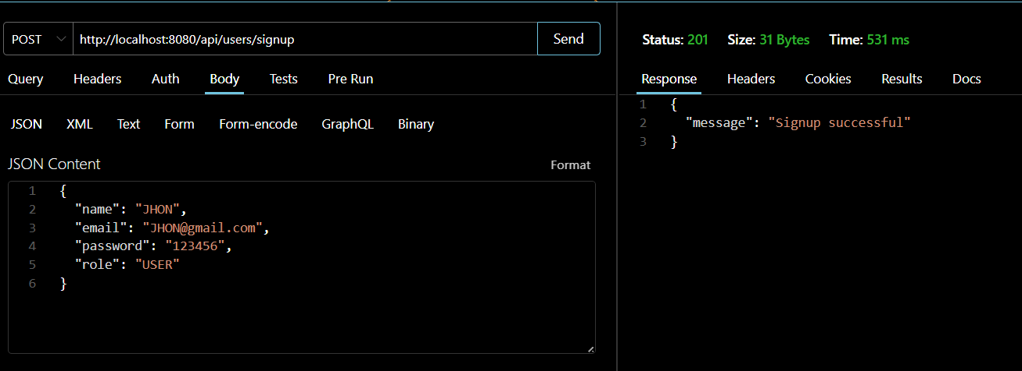[ Paste screenshot here: Test 1: Signup ]
Test 2: Signup with the same email (duplicate)
Enter the URL:
http://localhost:8080/api/users/signup
Send the following JSON:
{
"name": "jhon",
"email": "jhon@gmail.com",
"password": "123456",
"role": "USER"
}

Click:
Send
Expected Response
{
"message": "Email already registered"
}

The response status should be:
409 Conflict

Test 3: Signup with invalid data
Enter the URL:
http://localhost:8080/api/users/signup
Send the following JSON:
{
"name": "",
"email": "wrong-email",
"password": "123"
}

Click:
Send
Expected Response
{
"message": "Validation failed",
"errors": {
"name": "Name is required",
"email": "Invalid email format",
"password": "Password must be between 6 and 72 characters"
}
}

The response status should be:
400 Bad Request
Test 4: Signin with correct details
Enter the URL:
http://localhost:8080/api/users/signin
Send the following JSON:
{
"email": "jhon@gmail.com",
"password": "123456"
}

Click:
Send
Expected Response
{
"message": "Signin successful",
"userId": 1,
"name": "jhon",
"email": "jhon@gmail.com",
"role": "USER"
}

The response status should be:
200 OK
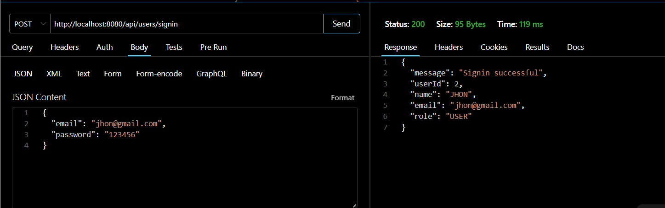[ Paste screenshot here: Test 4: Signin with correct details ]
Test 5: Signin with wrong password
Enter the URL:
http://localhost:8080/api/users/signin
Send the following JSON:
{
"email": "jhon@gmail.com",
"password": "wrongpassword"
}

Click:
Send
Expected Response
{
"message": "Incorrect password"
}

The response status should be:
401 Unauthorized

Test 6: Signin with unknown email
Enter the URL:
http://localhost:8080/api/users/signin
Send the following JSON:
{
"email": "unknown@gmail.com",
"password": "123456"
}

Click:
Send
Expected Response
{
"message": "User not found with this email"
}

The response status should be:
404 Not Found
13. Verify Users in MySQL
Open MySQL Workbench and run:
USE ecommerce;

SHOW TABLES;

DESCRIBE users;

SELECT user_id, name, email, role
FROM users;

Expected Output
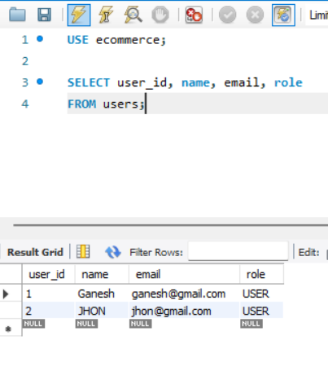
To show that the password is stored as a BCrypt hash, run:
SELECT email, password FROM users;
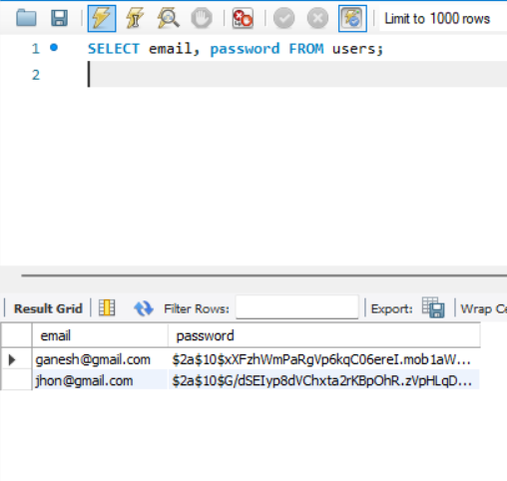

The password column shows a value starting with $2a$10$... and not 123456.
14. Result
The User Entity was successfully created using Spring Data JPA. REST APIs for signup and signin were implemented with validation and BCrypt password hashing using MySQL. The APIs were tested using Thunder Client and the registered user was verified in the users table.
Therefore, the experiment "User Signup and Signin" was successfully completed.

